Introduction
This documents describes how to install the two libraries GLEW and FreeGLUT on your own Windows computers.
- GLEW is a library that is needed to use the OpenGL 3.2 API
- FreeGLUT is a library used to create a rendering context (a window) as well as interaction with the window (mouse input, keyboard input, animation timers, etc).

The following description is taken from ( http://openglbook.com/setting-up-opengl-glew-and-freeglut-in-visual-c/ ).

We will use the 32-bit versions (also on 64-bit Windows).

Step 1: Get the Libraries
- Download the binary version for MSVC of FreeGLUT from this website ( http://www.transmissionzero.co.uk/software/freeglut-devel/ ) , make sure the version you get it 2.8.1 or higher (freeglut 2.8.1 MSVC Package).
- Download the latest 32-bit binary version of GLEW from their site ( http://glew.sourceforge.net/ ).

Step 2: Copy the Libraries
Decompress the files you just downloaded and open up the folder for FreeGLUT:
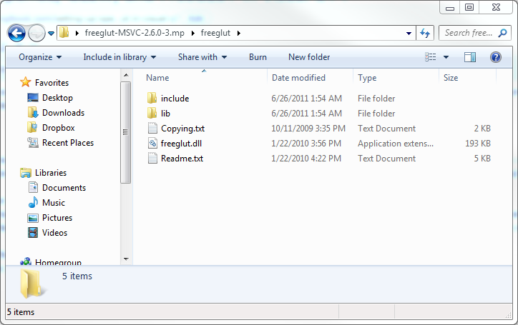
Open up another explorer window, and type %PROGRAMFILES% in the address bar, or %PROGRAMFILES(X86)% only if you’re on a 64-bit system. Find the sub folder
Microsoft Visual Studio 11.0\VC (from now on called the VC folder):
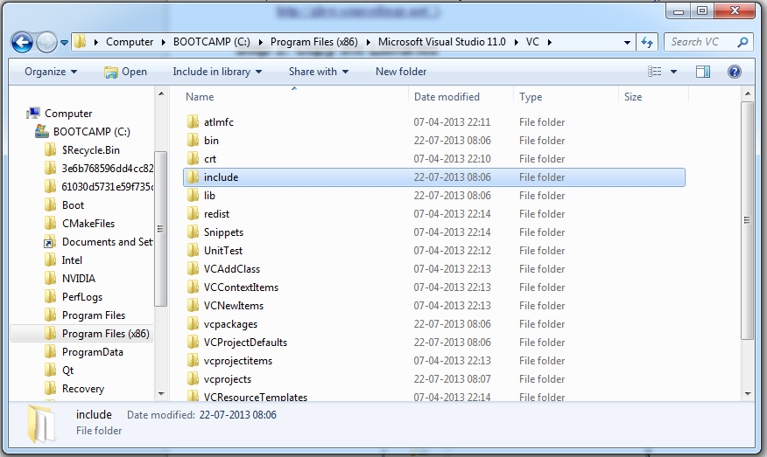
Copy the freeglut.lib from FreeGLUT’s lib folder into the VC's Lib folder.
Copy the contents from FreeGLUT’s include\GL folder into the VC's Include\GL folder (you have to create the GL folder yourself if it does not exist).
Copy the freeglut.dll from the FreeGLUT's bin folder into c:\Windows\System32 (on a 32 bit windows) or c:\Windows\SysWOW64 (on a 64 bit Windows)

Now, in the Explorer window currently pointed to FreeGLUT’s location, navigate to the location where you extracted GLEW:

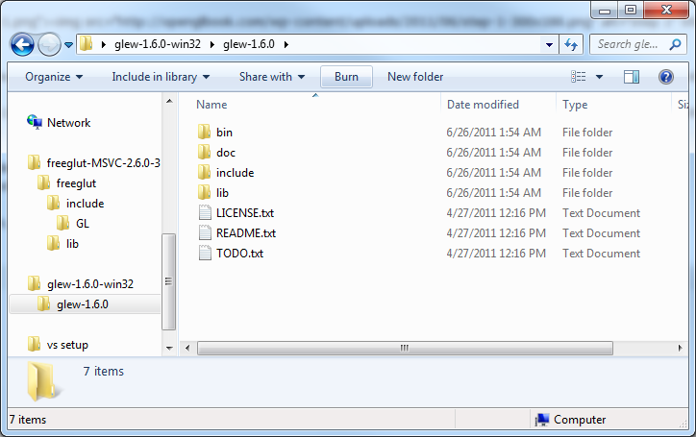
Copy the contents from GLEW’s lib\Release\win32 folder into the VC’s Lib folder.
Copy the contents from GLEW’s lib\Release MX\win32 folder into the VC’s Lib folder.
Copy the contents from GLEW’s include\GL folder into the VC’s Include\gl folder.
Copy the contents from the GLEW’s bin\Release\Win32 folder into c:\Windows\System32 (on a 32 bit windows) or c:\Windows\SysWOW64 (on a 64 bit Windows)
Copy the contents from the GLEW’s bin\Release MX\Win32 folder into c:\Windows\System32 (on a 32 bit windows) or c:\Windows\SysWOW64 (on a 64 bit Windows)

Slightly modified – now copying the dlls to Window System 32

